Systems overview:

The system will comprise of the following key hardware systems:
Base:
Most of the work for the self-localising base was completed as part of Toms 3rd year project. The key components of the base are:
- Chassis
- Motors/driver
- LIDAR
- Laptop
- Batteries (power supply)
- Encoders
For more information on the base of the robot (including functionality and work done), please look here: https://github.com/carebare47/dalek/blob/master/Autonomous%20Dalek%20Project%20Report.docx

Arm:
The arm we will be using was designed by Martin Stoelen. We will be borrowing it for the duration of the project. The arm uses co-contracting agonist-antagonist pairs of motors to vary the stiffness over several key joints allowing the compliance over these joints to be set.

Gripper:
The gripper will be primarily build from 3D printed parts and eight servos. The gripper will have four ‘fingers’, the design of which is inspired by the fin-ray effect gripper. A paper describing the original fin-ray gripper can be found here: https://www.frontiersin.org/articles/10.3389/frobt.2016.00070/full

Cameras:
The robot will use at least two cameras. The first (hand camera), mounted in the gripper, will be used for precise grasping of the object. The second camera (head camera) will be mounted on the highest point of the robot and will serve to identify and store the locations of objects.

Base sensors:
The base of the robot is equipped with two incrimental wheel encoders and a 2D LIDAR. The encoders are used to limit the velocity of the wheels to prevent the robot moving faster than the SLAM system is able to keep track of.

The system will comprise of the following key software systems:

Navigation:
The majority of the navigation system has already been developed. More information on this can be found in the git repository linked above.

Arm:
The arm has a kinematic model/solver, but does not come with high-level control algorithms. A node will be written to generate end-effector goals for the arm from both camera systems.

Gripper:
A control program will be developed to provide an abstracted interface to control of the grippers servos. Control inputs to this program will include the triggering of sequences of poses and control over individual servo angles. This program will also generate control signals for the LED ring array around the hand camera.

Gripper camera:
This program will process fiducials seen by the hand camera and generate signals instructing the arm to align the gripper with the object to be grasped. The program will also trigger the gripper closing when it in position.

Head camera:
The software for the head camera will detect objects as the robot drives around and send their locations to the waypoint node to be saved. In addition, the head camera program will be used to point the hand camera at the object we wish to pick up.

Waypoint node:
The waypoint node will serve as the universal goal coordinate saving and loading system. The robot base can currently save its current location as a waypoint. If the robot moves somewhere else and this waypoint is loaded as a goal for the navigation system, the robot will return to where it was when the waypoint was saved. This node will have the following inputs and outputs:
Node inputs:
- Should it save a waypoint?
- Should it be where I am or somewhere else?
- With respect to which coordinate frame should it save the waypoint?
- What should it label the waypoint?
- Should it load a waypoint?
- Which waypoint should it load?

The output of this node will be goals published for the navigation system to head towards.

Research, development and testing has to be done on the cascaded vision systems as they have conflicting requirements.

We are still uncertain of the methods we will use for identifying and localising objects with each camera system.
Head camera:
Our options for the head camera are YOLO or fiducials. YOLO is a neural-network based realtime object detection and localisation system. It identifies and localises objects in a camera feed or still picture. Is we use YOLO for the head camera, we will modify the program found here (https://github.com/pjreddie/darknet/wiki/YOLO:-Real-Time-Object-Detection) to return the CofM of the identified objects. This CofM will then be located in the RGBD image stream from the kinect, where the depth value of the identified object will be calculated and thus the location of the object will be known. Development has not yet started on this solution and only preliminary research has been done to assess the feasability of making this system.

The other option for the head camera is fiducials. If we use this approach, QR codes will be attached to the object we wish to recognise. If a fiducial is seen in a camera feed, the location of the fiducial can be calcualted.

Hand camera:
Fiducials are a better option for the hand camera as YOLO must see the entire object to identify it. As the gripper closes in on an object, the objects apparent size will increase until the edges of the object are no longer visable. When this happens it becomes impossible to calculate the CofM of the object and thus the gripper cannot be properly aligned to grasp the object.

A small QR code on the object could be used to guide the hand camera. The extent to which placing a QR code for the hand camera on the object will obscure the YOLO identification is currently unknown.

The hand camera requires the fiducial to be small in order to be detectable at close range, whereas the head camera requires the fiducial to be large in order to identify the object at long range. The gripper will have a maximum size of object that it can pick up. It is possible that a fiducial covering an entire face of the largest object that the gripper can grasp may not be large enough to detect at a range of more than 1.5 meters.

Another option to address both systems is fractal fiducials as can be seen in image XXXX [1]. This would allow the head camera to see the object far away whilst providing the hand camera with smaller fiducials to track. The data in each sub-fiducial can contain the fiducials coordinate and level within the larger fidicial. Again, only preliminary research has been done into the feasability of this approach
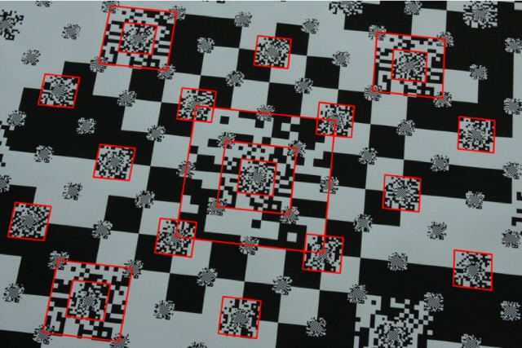

A high priority in the early stages of our project development is to find out how well we can idenfity fiducials at a distance. Data on camera resolution, fiducial size and distance to fiducial will be collected for both camera systems and a graph will be generated for both regular and fractal fiducials. From this we will be able to see which approach (or combination of approaches) will be most suitable.
Bad res/distance:
If the graph shows that the size of fiducial required for the headcam to detect is larger than the largest object the gripper can pick up, then we will look into higher resolution head cameras. If, with high resolution cameras, it is still not possible to detect objects at a reasonable range, then the scope of the project will have to be quickly reevaluated.

Reasonable res/distance:
Fractal QR codes and YOLO localisation in 3D will be investigated further to find the relative reliability and feasability of each approach with emphesis on reducing required development time and finding a robust solution.

[1]A. Herout, M. Zachariáš, M. Dubská and J. Havel, "Fractal marker fields: No more scale limitations for fiduciary markers," 2012 IEEE International Symposium on Mixed and Augmented Reality (ISMAR), Atlanta, GA, 2012, pp. 285-286.
doi: 10.1109/ISMAR.2012.6402576
keywords: {augmented reality;cameras;fractals;image motion analysis;FMF;QR-code;camera motion;camera-based augmented reality;data matrix;embedding marker;fiduciary marker;fractal marker field;fractal structure;marker constant density;marker field surface;matrix code;Augmented reality;Calibration;Cameras;Fractals;Image color analysis;Manganese;Reliability},
URL: http://ieeexplore.ieee.org/stamp/stamp.jsp?tp=&arnumber=6402576&isnumber=6402509

Risk management:
Please see the Risk_management.ods spreadsheet for our risk register, analysis and reduction strategies.

Team organisation:
The team for this project comprises of Tom Queen and Daniel Gregory-Turner. Tasks have been assigned to our respective strengths where possible. By default, electronics work falls to Tom and CAD/mechanical work falls to Dan. We both have experience with ROS (Robot Operating System).

